Story Board

There are 8 steps you can take towards World Peace by using Icebreakers. Follow the story board below for more details on the step-by-step instructions to help catalyze world peace.
Step 1. Log into GWA and navigate to 'Find Another Heart' screen.
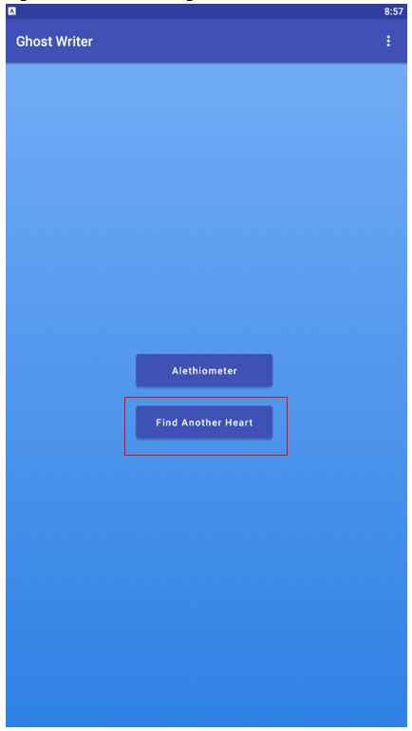
Step 2. Enter in the search details for the type of heart you are searching for. Click Search.
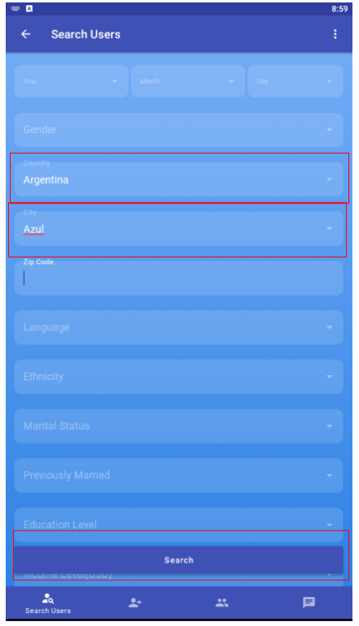
Step 3. Click on a user you wish to chat with.
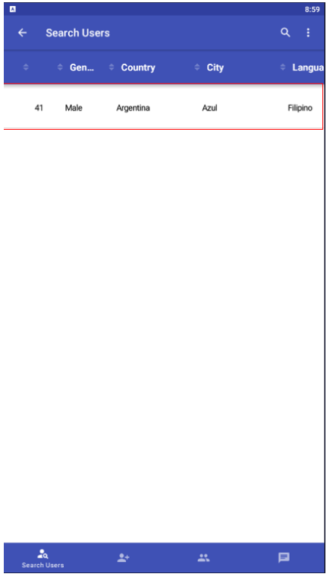
Step 4. Click on the 'Chat Request' button.
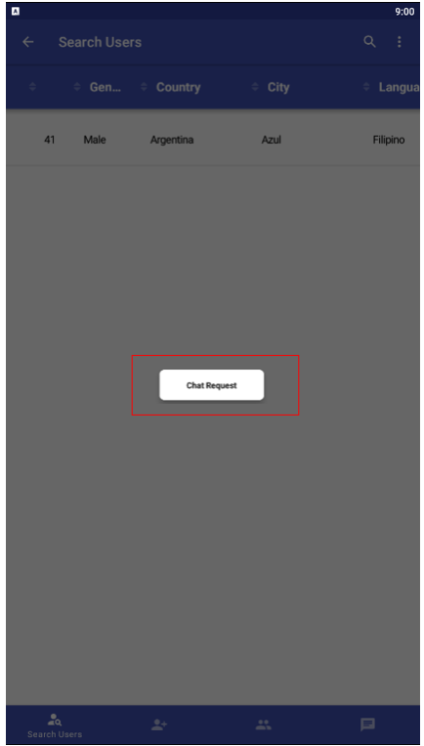
Step 5. Enter in the question you have and the symbols that represent the question. Click 'Send Request' button. For this example, I use Candle, Lute & Globe to represent the question ‘What have you noticed about our culture that seems very different from their own?’.
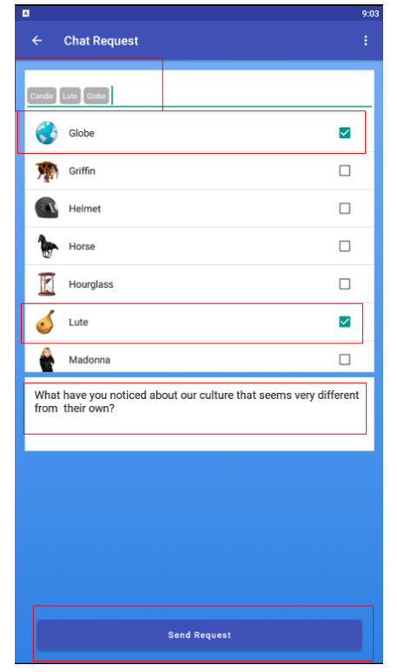
Step 6. Go to the 'Chat Request' window and select the chat you just started. You will have to wait for the other user to accept the chat before you can start chatting.
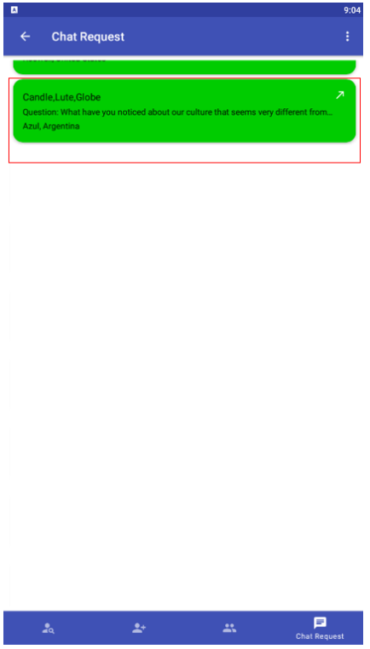
Step 7. The other user accepts the chat request.
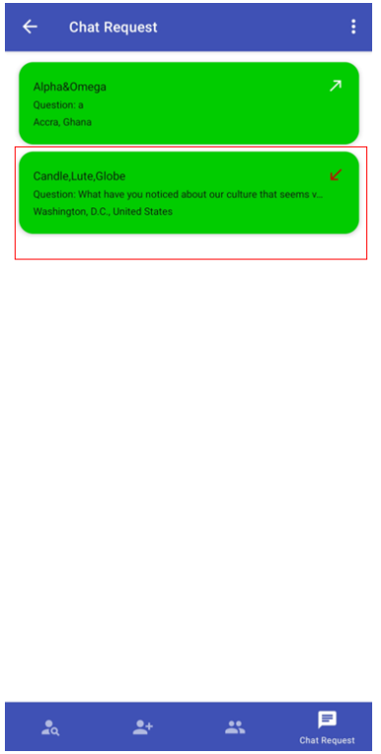

Step 8. You both start chatting over the stream images and see if you connect or not.
